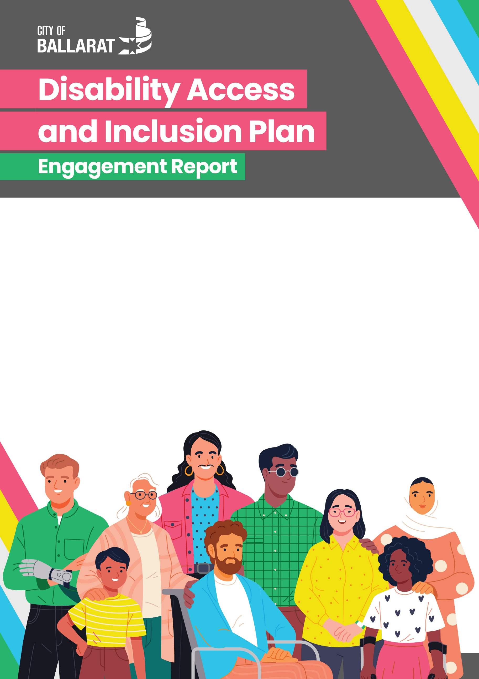

Overview
The City of Ballarat’s Draft Disability Access and Inclusion Plan (DAIP) 2026–2030 was on public exhibition between 1 June and 1 July 2026. The DAIP was informed by extensive community engagement with 325 people living with disability, carers and organisational representatives from 54 organisations between 16 February and 22 March 2026.
To provide feedback on the Draft Plan, a short online survey was developed with a mix of open and closed-ended questions. These questions focused on:
- the suitability of the Plan to the City of Ballarat’s role in disability access and inclusion
- the clarity of the Plan
- whether the Plan meets community expectations of what the City of Ballarat should do to improve disability access and inclusion
- what could make the DAIP better.
The Draft DAIP was published on the City of Ballarat’s MySay webpage and promoted widely to stakeholders, the community, participants in the initial engagement and the City of Ballarat Disability Advisory Committee.

Engagement in Public Exhibition
Summary of Engagement
During the exhibition period, a total of 17 responses were received through the MySay survey and 10 Disability Advisory Committee members were engaged. The Draft DAIP was downloaded 204 times. As part of the public exhibition engagement process, a workshop with the City of Ballarat Disability Advisory Committee was held on 12 June 2026. This workshop provided an opportunity for Committee members to review the Draft Plan in depth, discuss feedback and identify opportunities to strengthen the Plan’s overall content, priorities, actions and outcomes. Feedback from the Committee, alongside public exhibition submissions, helped inform the final Plan.
MySay Survey Data
Of the people who responded to the MySay survey:
- 70.6% had reviewed the Draft Plan in detail.
- 82.2% stated that the Draft Plan was either very suitable or mostly suitable to the City of Ballarat’s role in addressing barriers experienced by people living with disability, with 41.1% selecting each response.
- 88.1% stated that the Draft Plan either meets or somewhat meets their expectations of what the City of Ballarat should do to improve disability access and inclusion. This included 41.1% who stated that it meets their expectations and 47% who stated that it somewhat meets their expectations.
- 64.9% stated that the Draft Plan was either very clear or mostly clear and easy to understand, including 29.4% who stated it was very clear and 35.5% who stated it was mostly clear.
- 11% stated that the Draft Plan did not meet their expectations.
Who we heard from
The majority of survey respondents were people living with disability (82.3%), while 17.6% identified as carers. The majority of respondents were women (58.8%), followed by men (35.3%), with 5% preferring not to say. A mix of age groups participated in the survey:
- 12–25 years – 5.8%
- 26–35 years – 5.8%
- 36–45 years – 17.6%
- 46–55 years – 29.4%
- 56–65 years – 11.6%
- 66–75 years – 23.5%.
Overview of Feedback
Feedback received through public exhibition identified a number of opportunities to strengthen the Draft DAIP, including:
- Strengthening the Community Profile to reflect the broader prevalence of disability, as well as people living with long-term health conditions.
- Increasing the use of person-first language throughout the Plan.
- Addressing gender-based violence experienced by people living with disability in the Plan.
- Strengthening references to carers, including outlining support for carers within the actions.
- Strengthening the focus on employment outcomes for people living with disability.
- Providing greater clarity in the Action Plan, particularly the distinction between strategic actions and deliverables.
- Strengthening the representation of people living with disability in the arts and actions to increase this representation.
- Strengthening references to universal design, including going beyond minimum standards and compliance towards best practice.
- Providing greater clarity in the original Outcomes Framework, with feedback indicating that the original framework was difficult to understand and required clearer explanation.
- Including more explicit actions to improve communication for people with lower English literacy levels, people with intellectual disability and people who are less digitally connected.
Feedback received through public exhibition and the Disability Advisory Committee workshop was considered in finalising the Disability Access and Inclusion Plan 2026–2030.

