Registering your Group's interest in activating the Llanberris Reserve Pavilion

As Llanberris Reserve enters a new chapter, we are keen to hear from community groups who may be interested in using the Pavilion as a shared community space. We want to understand how your group might use the building in a way that benefits the wider community and how your activities may bring the Reserve to life in a positive way.

To help you get a feel for the space, we are hosting guided tours of the facility. These tours provide an opportunity to see the facility firsthand, ask questions, and consider how it could support community-focused activity. Tours are highly encouraged and open to attend.

Tours will be conducted on:
- Monday 27 April, 11.30am to 12 noon
- Wednesday 20 May, 5.30pm to 6pm

This process in an early ideas-based process and not a formal leasing or allocation process. Please note that groups must be incorporated not-for-profits and hold current public liability insurance. To register your interest in the building we ask that you complete the following short form. This form will close Thursday 28 May 2026.

If you have any questions about the process, please use the Contact Us details below.
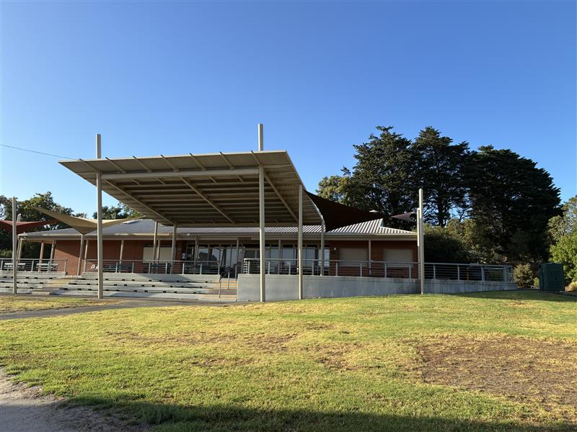
Picture of the Llanberris Pavilion that currently serves as Athletics Ballarat’s current clubrooms
1. If the Pavilion (pictured above) at Llanberris Reserve was available for community use, how might your group use it in a way that is inclusive and delivers benefits to the wider community? ^{Required}
2. What would successful community use of the Pavilion look like from your group's perspective? ^{Required}
Name of organisation: ^{Required}
Contact details: ^{Required}
We confirm that our group is an incorporated, not-for-profit organisation and that we hold current public liability insurance. ^{Required}

Yes

Please return via the reply-paid envelope or via post to or hand deliver to:

Phoenix Building – Customer Services
25 Armstrong Street South
Ballarat VIC 3350

