Buninyong Botanic Garden - Baths Garden Concept Plans

Your Connections to the Gardens

- Where do you live? ^{Required}
Select one answer only

Addington
Alfredton
Ascot
Bakery Hill
Ballarat Central
Ballarat East
Ballarat North
Black Hill
Bonshaw
Brown Hill
Buninyong
Bunkers Hill
Canadian
Cardigan
Cardigan Village
Delacombe
Eureka
Golden Point
Invermay Park
Lake Gardens
Lake Wendouree
Lucas
Magpie
Miners Rest
Mitchell Park
Mount Clear
Mount Helen
Mount Pleasant
Mount Rowan
Nerrina
Newington
Redan
Sebastopol
Smythes Creek
Soldiers Hill
Warrenheip
Wendouree
Windermere
Winter Valley
Outside the City of Ballarat
Other (please specify):

- How often do you visit the Buninyong Botanic Gardens? ^{Required}
Select one answer only
Daily
At least once a week
At least once a month
A few times a year
Rarely
This is my first visit / I don’t usually visit
I haven't visited the gardens
- Are you connected with any of the following groups or organisations? ^{Required}
Select all that apply

Friends of the Buninyong Botanic Gardens
Buninyong and District Community Association
Buninyong and District Historical Society
I’m not connected with any of these groups
Other (please specify)

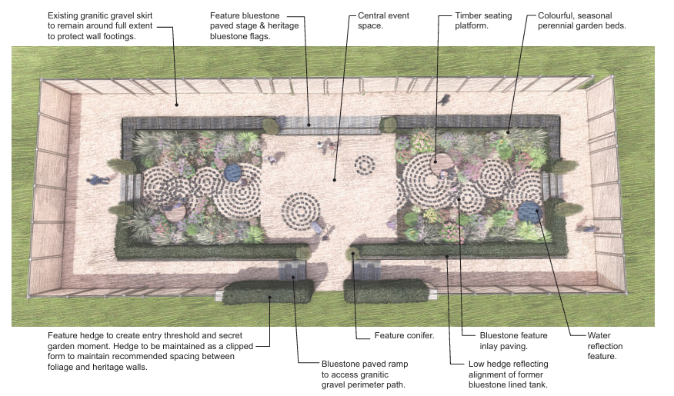
- How well do you think the draft concept plans: ^{Required}
Respect the heritage of the site
Strongly Agree
Agree
Neutral
Disagree
Strongly Disagree
Meet community needs
Strongly Agree
Agree
Neutral
Disagree
Strongly Disagree
Create an attractive garden
Strongly Agree
Agree
Neutral
Disagree
Strongly Disagree
- Is there anything you would like us to consider before the concept plans are finalised?
This question is optional.

About You
We want to hear from the wide and diverse range of people who make up Ballarat and the surrounding region. The City of Ballarat’s Inclusion Framework guides us in listening to all voices, especially those who may not always be heard, so that the different needs and perspectives in our community can be understood and represented. Your answers to the following questions help us ensure that everyone has an opportunity to participate. Your responses are anonymous, secure, and confidential. Each question includes a “Prefer not to say” option.

- Which of the following best describes your gender? ^{Required}
Select one answer only
Man
Woman
Non-binary
Prefer not to say
Self-describe:

- Please select your age group: ^{Required}
Select one answer only
Under 12
12 to 25
26 to 35
36 to 45
46 to 55
56 to 65
66 to 75
76 to 85
86+
Prefer not to say
- Do any of the following apply to you? ^{Required}
Select all that apply
I identify as LGBTQIA+
I am Aboriginal and/or Torres Strait Islander
I am a person with disability or chronic health condition
I am from a culturally and linguistically diverse (CALD) background
I earn less than $650 per week, receive a government pension or allowance, or hold a Health Care Card
None of the above
Prefer not to say

