Reimagining Llanberris Reserve Community Survey

1. What statement best describes your connection to Llanberris Reserve: ^{Required}
Select one answer only

I live nearby
I regularly use the Reserve for organised sport
I use the Reserve for casual training
I visit the Reserve occasionally
I haven't used the Reserve but would like to
I have never visited the Reserve
Other

This engagement focuses on the area within the blue line shown on the map below, which includes the athletics track, on-site parking areas, and existing buildings such as the Llanberris Reserve Pavilion, the storage sheds and the Tom Roberts Pavilion. The two clubrooms on the corner of Young and York Streets, currently home to the Harriers and Ballarat YCW, as well as the neighbouring Netball Stadium are not within the scope of this engagement.

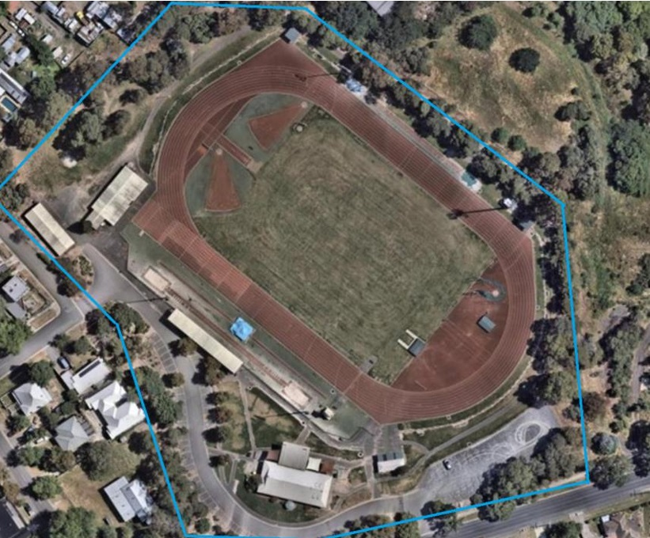
2. What do you believe is the best future use of Llanberris Reserve? ^{Required}
Think about how people of different ages, abilities, or backgrounds could use and enjoy this space.

As a part of planning for the future of Llanberris Reserve, there is also an opportunity for us to work with the community to uncover ideas for the use of the small brick building onsite, known as the Tom Roberts Pavilion. It is too small for a lot of community uses but we are encouraging community members to come up with ideas that would support broader community benefit.

If you are a community group that may be interested in the Llanberris Reserve Pavilion, please provide a separate submission that you can find on the home page for this project.
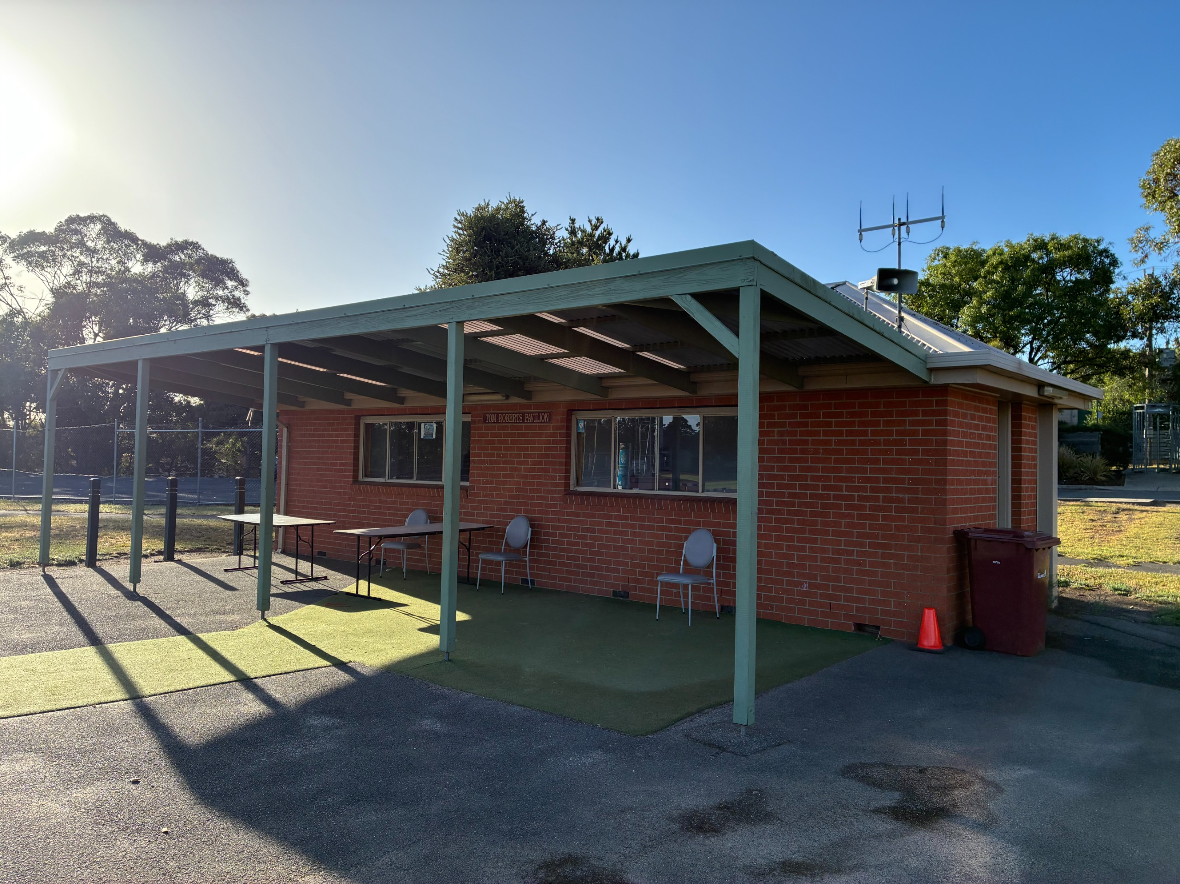
3. What is your idea for the small brick building, currently known as the Tom Roberts Pavilion, within Llanberris Reserve? ^{Required}
4. Is there anything else you would like to share about the future of Llanberris Reserve?

About You
We want to hear from the wide range of people that make up the Ballarat community. The City of Ballarat's Inclusion Framework guides us in listening to all voices - especially those that may not always be heard - so that different needs and perspectives in our community can be heard and understood.

Your answers to the following questions help us ensure that everyone has an opportunity to participate. Your responses are anonymous, secure and confidential.
5. Which of the following best describes your gender? ^{Required}
Select one answer only
Man
Woman
Non-binary
Prefer not to say
Other

6. Please select your age group: ^{Required}
Select one answer only
Under 12
12-15
16 to 25
26 to 35
36 to 45
46 to 55
56 to 65
66 to 75
76 to 85
86+

7. Do any of the following apply to you? ^{Required}
Select all that apply

I am a person with disability or chronic health condition
I am a carer
I identify as LGBTQIA+
I am Aboriginal and/or Torres Strait Islander
I am from a culturally and linguistically diverse background (CALD)
I earn less than $650 per week, receive a government pension or allowance, or hold a Health Care Card
None of the above
Prefer not to say

Thank you for participating in this engagement. Your responses will be used to develop a shared vision and a set of guiding principles that will inform future decisions. We will report back on what we heard and how it shaped the outcomes.

Please return via the reply-paid envelope or via post to or hand deliver to:

Phoenix Building – Customer Services
25 Armstrong Street South
Ballarat VIC 3350

