Have your say on Council’s budget process
Each year Council prepares a budget to deliver services, projects and infrastructure for the Ballarat community. We want to make it easier for everyone to understand how the budget works and check whether community priorities identified in 2024 are still on track. This short survey takes less than 5 minutes, and your feedback will help guide how we plan and share information in future.

Section 1: Budget process and priorities
These questions help us understand how clear and useful our budget information is for the community

- How clear is the information about Council’s budget process? ^{Required}
Not clear - Very clear
___ / 5
- Overall, how informed do you feel about how Council’s budget process works? ^{Required}
Not informed - Very informed
___ / 5
In late 2024, almost 2,000 community members shared their views to help shape the Council Plan 2025–2029. We’d like to check in to see if those priorities still reflect what matters most for future budgets.
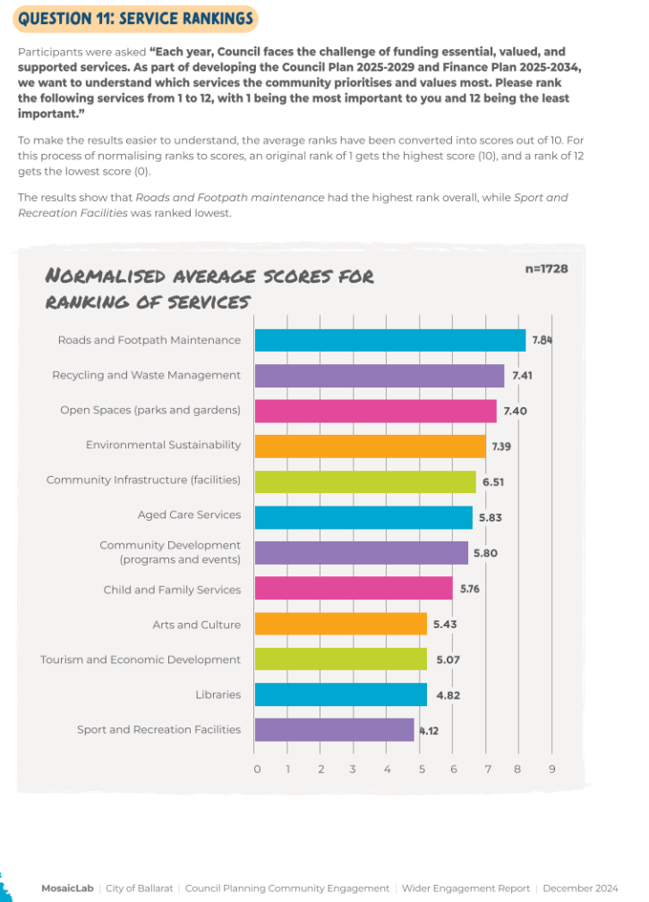
Bar chart showing average community rankings of Council services from the 2024 Council Plan engagement (1,728 participants). Roads and footpath maintenance received the highest overall ranking, followed by recycling and waste management, and open spaces such as parks and gardens. Lower-ranked services included libraries, tourism and economic development, and sport and recreation facilities.
- Do you agree these priorities still reflect our community’s needs? ^{Required}
In 2024, the community ranked the services most important to them. Here’s what we heard.
Select one answer only

Yes - I agree these priorities still reflect our community’s needs overall
Mostly - they reflect our community overall, but some should change (please tell us more)
No - I don’t feel these priorities reflect our community’s needs (please tell us more)
- If you answered 'mostly' or 'no', please tell us what themes or focus areas you think should be added, changed or give mor attention in the budget? ^{Required}

Section 2: Questions and feedback - Optional
Here you can tell us what you’d like to know more about, how you’d prefer to engage with Council, or share any other feedback on the annual budget.

- Is there anything you’d like to know more about when it comes to Council’s budget or financial planning?
This question is optional.

When will my feedback be considered?
To be considered as part of the upcoming Budget development process, feedback must be received by 15 November each year. Feedback received after 15 November will still be considered and will inform the following year’s Budget development process.
For example: Feedback received by 15 November 2026 will be considered as part of the development of the Council's 2027/28 Budget.
- What would you like to tell us about Council’s budget?
You can use this space to provide feedback, ask a question, suggest something for consideration, or tell us about a budget priority that is important to you. This question is optional.

Section 3: Contacting Council - Optional
You can request a response by email or phone, or ask to speak with a Council officer.

- Would you like a Council officer to contact you about your question or feedback? ^{Required}
This question is optional.
Select one answer only
Yes, by email
Yes, by phone
Yes, I’d like to arrange a time to speak with a Council officer
No, I don’t need a response
Other (please specify)

- Name: ^{Required}
- Email address: ^{Required}
- Contact phone number: ^{Required}

Section 4: About You
We want to hear from the wide and diverse range of people who make up Ballarat and the surrounding region.
These questions help us understand who we are hearing from and whether a broad cross-section of the community has participated. Demographic information and any contact details you provide will be separated from your feedback when survey results are analysed and reported.

- Which of the following best describes your gender? ^{Required}
Select one answer only
Man
Woman
Non-binary
Prefer not to say
Self-describe:

- Please select your age group: ^{Required}
Select one answer only
Under 12
12 to 25
26 to 35
36 to 45
46 to 55
56 to 65
66 to 75
76 to 85
86+
Prefer not to say
- Do any of the following apply to you? ^{Required}
Select all that apply

I identify as LGBTQIA+
I am Aboriginal and/or Torres Strait Islander
I am a person with disability or chronic health condition
I am from a culturally and linguistically diverse (CALD) background
I earn less than $650 per week, receive a government pension or allowance, or hold a Health Care Card
None of the above
Prefer not to say

How we’ll use your contact details- Privacy Statement

If you request a response, phone call or meeting with a Council officer, we’ll use the contact details you provide to respond to your enquiry or arrange a suitable time to meet.

Your personal information is collected by the City of Ballarat in accordance with our Privacy Policy and will only be used for the purpose of responding to your enquiry and administering this engagement.

Your information will be securely stored in Council’s systems and handled in accordance with the Privacy and Data Protection Act 2014 (Vic). For more information, please refer to Council’s Privacy Policy at www.ballarat.vic.gov.au.

